HOLY CROSS CONVENT SENIOR SECONDARY SCHOOL,AMBIKAPUR

CLASS - IV
SUBJECT - ENGLISH GRAMMAR

Note: Students are instructed to write the following notes in their English grammar book with pencil.
Students not having the book can practice it in their English practice copy.

- NOUNS - NUMBER

Nouns have two numbers : singular number and plural numbers.

SINGULAR
The word singular means single or one. Book, pen, dog, boy, ox, man are all singular.

PLURAL
The word plural means more than one. Books, pens, dogs, boys, oxen, men are all plural.

FORMATION OF PLURALS

- REGULAR PLURALS

Regular plurals end in s, es or ies. They are formed in the following ways :
- By adding the letter -s to the singular forms :

Singular | book | cow | girl | desk
Plural | books | cows | girls | desks

- Nouns ending in -ss, -sh, -ch (soft) or -x form their plural by adding -es to their singular :

Singular | class | kiss | brush | watch | box
Plural | classes | kisses | brushes | watches | boxes

- Nouns ending in -o also from their plural by adding -es to their singular :

Singular | buffalo | mango | hero | potato
Plural | buffaloes | mangoes | heroes | potatoes

A few nouns though they end with -o form their plural by adding -s to their singulars :

Singular | photo | piano | ratio | stereo
Plural | photos | pianos | ratios | stereos

- Nouns which end in -y after a consonant, form their plural by changing -y into -i and adding -es.

Singular | baby | fly | lady | army | story
Plural | babies | flies | ladies | armies | stories
But if a noun ends in -y after a vowel, it forms its plural by adding -s to its singular form.
Singular | boy | bay | toy | key
Plural | boys | bays | toys | keys

- Nouns which end in -f or -fe form their plurals by changing -f or -fe into -v and adding -es.

Singular | life | leaf | wife | knife
Plural | lives | leaves | wives | knives
But a few nouns of this kind, however, form their plural by adding -s:
Singular | chief | proof | serf | safe
Plural | chiefs | proofs | serfs | safes

- IRREGULAR PLURALS
The nouns that form their plurals irregularly, are called irregular plurals.

- Three nouns form their plurals by adding -en to the singular.

Singular | ox | child | brother
Plural | oxen | children | Brethren  (or brothers)

- A few nouns form their plurals by changing the vowel in the middle of the word.

Singular | man | woman | tooth | foot
Plural | men | women | teeth | feet

- SINGULAR AND PLURAL SAME

Singular | Sheep | deer | score | fish | fruit | innings
Plural | sheep | deer | score | fish | fruit | innings

- NOUNS THAT ARE ALWAYS PLURAL

alms | compasses | jeans | police
shorts | ashes | dividers | manners
riches | thanks | cattle | goods
pants | scissors | tongs | clothes
gentry | people | shears | trousers

- NOUNS THAT ARE ALWAYS SINGULAR

army | furniture | mathematics | physics
rice | crockery | hair | money
public | scenery | crowd | luggage
news | politics | wheat | innings

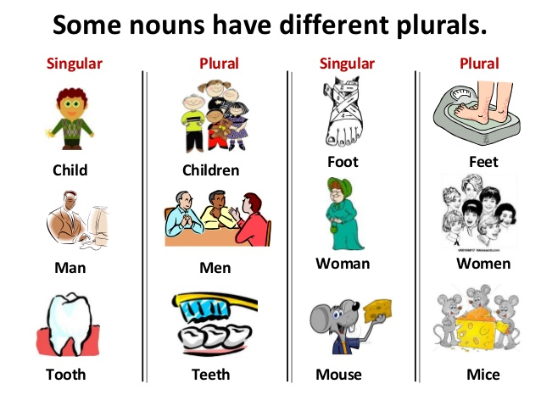
WORKSHEET

- Write the plural of each of these words:

Day : days church : churches
Monkey : monkeys mango : mangoes
Stereo : stereos cliff : cliffs
Loss : losses photo : photos
Crowd : crowd baby : babies
Child : children gentleman : gentlemen
Wife : wives half : halves

- Rewrite by changing the number of the noun in each of these sentences :

- I could hear the cry of the child.
I could hear the cry of the children.
- The horse eats grain but the cow eats grass.
The horses eat grain but the cows eat grass.
- Birds build their nests in the trees.
Bird builds her nest in the tree.
- My book is in my desk.
My books are in my desk.
- A dog barks and a cat meows.
Dogs bark and cats meow.
- The boy threw a stone at the bird.
The boys threw stones at the birds.

- Choose the correct word from the brackets:

- Houses have (roofs, roves).
Houses have roofs.
- She wants some more (rice, rices)
She wants some more rice.
- (Cows, cowes) give us milk.
Cows give us milk.
- She has two (babies, babys).
She has two babies.
- There are many (knifes, knives) on the table.
There are many knives on the table.
- Here are two (books, book).
Here are two books.
- Ram and Shyam are (friend, friends).
Ram and Shyam are friends.

